City and County of San Francisco, California Department of Technology, Digital Services Division

San Francisco Enterprise Geographic Information Systems Program (SFGIS) Prepared 2017-05-01

This dataset has been prepared for distribution under PDDL

[https://opendatacommons.org/licenses/pddl/1.0/](https://creativecommons.org/licenses/zero/1.0/legalcode)

Point of Contact:

Brian B. Quinn, Ph.D. GISP

*Architect / Analyst, SF Enterprise GIS Program Department of Technology*

*City and County of San Francisco brian.quinn (at) sfgov.org*

+1.415.581.4083 office

Motivation:

For some years, City and County of San Francisco has made available a set of features under the moniker “Building Footprints” that were in fact building masses, sometimes aggregating entire blocks of adjacent residential structures into a single complex structure. These features were somewhat adequate for cartography, but not suitable for any sort analysis at the level of individual structures.

To respond to State of California requirements for monitoring the energy efficiency of certain commercial structures (over 925 square meters), funding was obtained to have these building masses split into individual structures based on building vertices with parcel boundaries as guidance.

Once individual structure footprints were available, three LiDAR-derived grid surfaces (gridded at 50cm) were used to compile zonal statistics within each building footprint (as gridded at 25cm interval.) These statistics were calculated from an integer representation of bare-earth, first-return, and a grid difference of the two---denominated in centimeters. Evaluating by integers made possible the summary of median values over the full building footprint.

The three LiDAR-derived grids are described in the following three pages.

Bare Earth Surface [gnd]

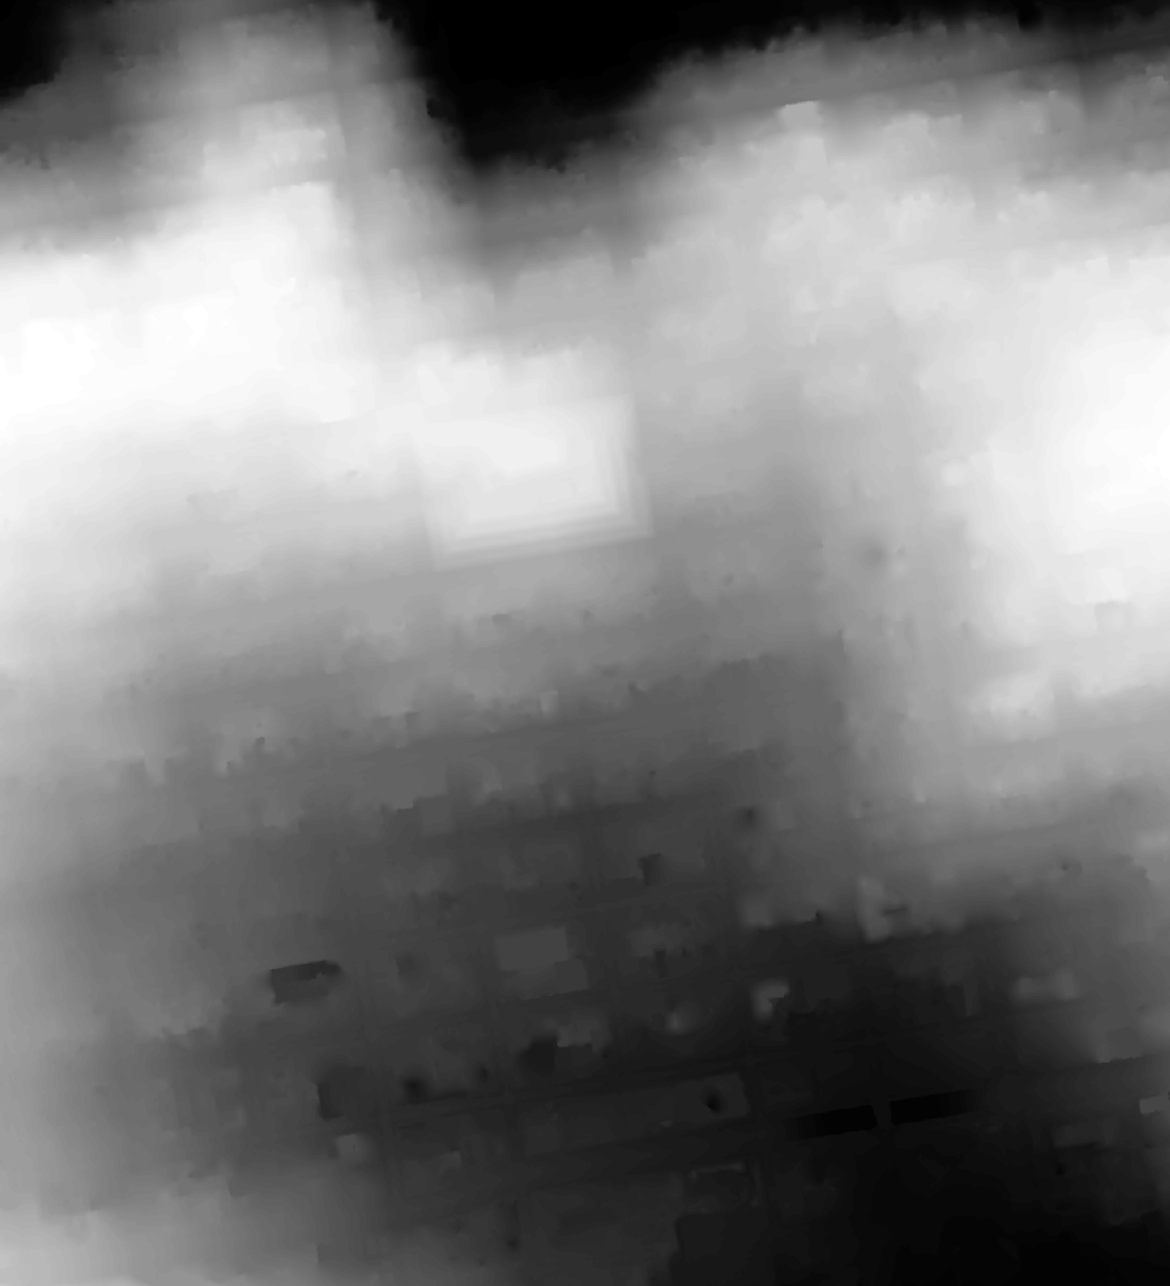

This is a 50cm gridded bare earth model, derived from 2 ppsm airborne LiDAR from Pictometry of 2010. Only ground-classified returns were compiled, and a natural neighbor (involving tesselation) algorithm was applied to interpolate across the gaps for every building and beneath the densest tree canopy. The grid was compiled and prepared in NAD 1983 (2011) San Francisco Coordinate System of 2013, denominated in meters (WKID=7131).

Zonal statistics were compiled for each building footprint based on a 25cm-gridded representation of the vector polygon, discrete for every structure. The 25cm grid representation of the building was co-registered with the 50cm gnd surface.

First Return Surface [1st]



This is a 50cm gridded first return model, derived from 2 ppsm airborne LiDAR from Pictometry of 2010. This surface shows the highest elevation infrared reflection from terrain, street, roof, and tree canopy. Only first returns were compiled, and a natural neighbor (involving tesselation) algorithm was applied to interpolate in areas of missing data. Morphological processing (grayscale dilation) was applied to the grid to mitigate scan artifacts and create more coherent roof surfaces. The grid was compiled and prepared in NAD 1983 (2011) San Francisco Coordinate System of 2013, denominated in meters (WKID=7131).

Zonal statistics were compiled for each building footprint based on a 25cm-gridded representation of the vector polygon, discrete for every structure. The 25cm grid representation of the building was co-registered with the 50cm gnd surface.

Feature Height Surface [hgt]

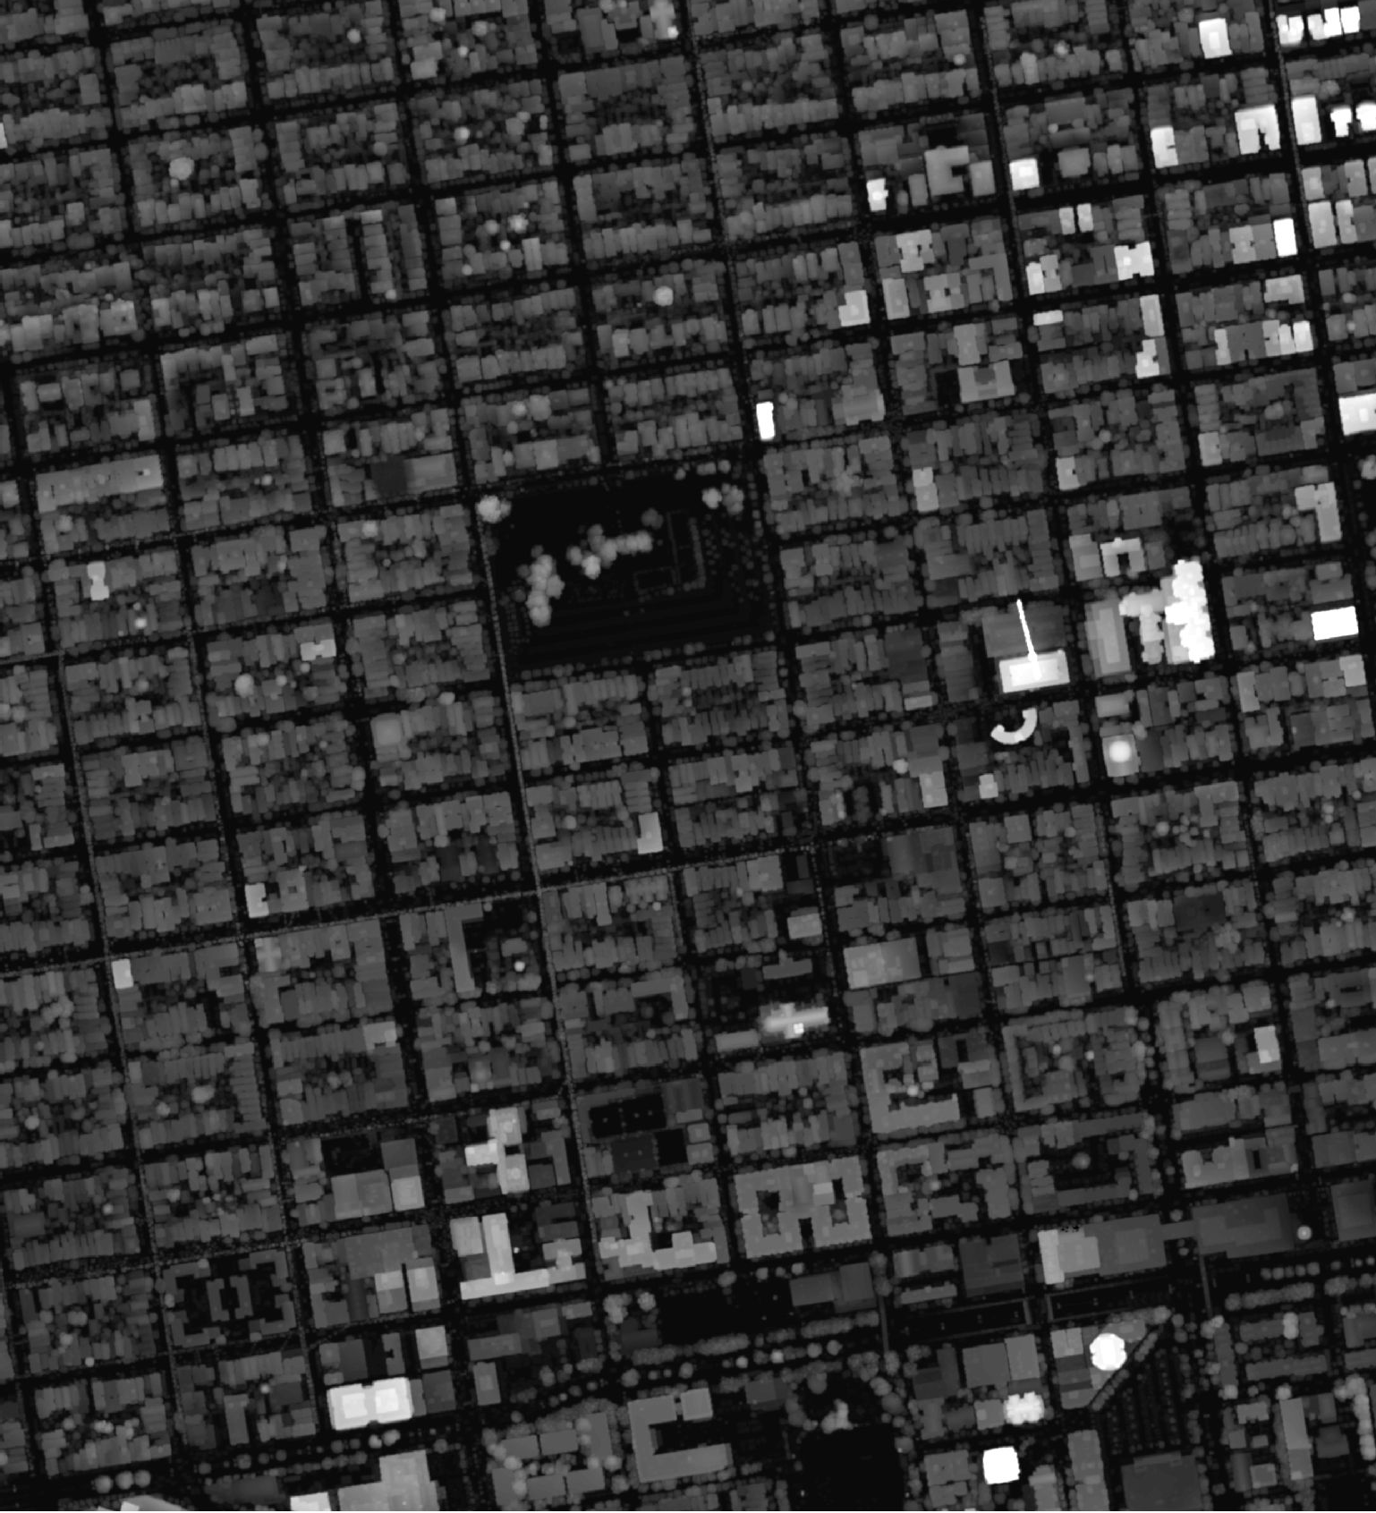

This is a 50cm gridded difference model, pixelwise-subtracting [First Return Surface -- Bare Earth Surface]. This surface shows the height above ground for structure roof and tree canopy. Effectively, the terrain has been removed and set to near zero. This grid combines the interpolation used in bare earth with the grayscale dilation used in the first return surface to provide an optimized estimate of LiDAR-derived structure height. The grid was compiled and prepared in NAD 1983 (2011) San Francisco Coordinate System of 2013, denominated in meters (WKID=7131).

Zonal statistics were compiled for each building footprint based on a 25cm-gridded representation of the vector polygon, discrete for every structure. The 25cm grid representation of the building was co-registered with the 50cm gnd surface.

|  |  |  |  |  |  |
| --- | --- | --- | --- | --- | --- |
|  |  |  |  |  |  |
|  | Based on review of Feature Class "sf13m_BldgFoot_withZ_20161005i_pgz" | | | |  |
|  | The name implies an SF13(meters)(7131) projection of San Francisco building footprint features, including Z-attribute values, in Polygon-Z data type | | | | |
|  | Field | *Name* | *Alias* | *Type* | *comment* |
|  | 1 | OBJECTID | OBJECTID | ObjectID | auto-generated unique ID key |
|  | 2 | Shape | Shape | Geometry | Polygon-Z type |
|  | 3 | sf16_BldgID | sf16_BldgID | char-14 | San Francisco Building ID using criteria of 2016-09, 6-char epoch, '.' , 7-char zero-padded AreaID or new ID in editing epochs after initial '201006.' |
|  | 4 | Area_ID | Area_ID | Long | Epoch 2010.06 Shape_Area sort of 177,023 building polygons with area > ~1 sq m |
|  | 5 | sf_MBLR | sf_MBLR | char-20 | San Francisco property key: Assessor's Map-Block-Lot of land parcel, plus Right-of-way area identifier derived from street Centerline Node Network (CNN) |
|  | 6 | P2010mass_ZminN88ft | P2010mass_ZminN88ft | Double | Input building mass (of 2010,) minimum Z vertex elevation, NAVD 1988 ft |
|  | 7 | P2010mass_ZmaxN88ft | P2010mass_ZmaxN88ft | Double | Input building mass (of 2010,) maximum Z vertex elevation, NAVD 1988 ft |
|  | 8 | gnd_cells50cm | gnd_cells50cm | Long | zonal statistic: LiDAR-derived ground surface grid, population of 50cm square cells sampled in this building's zone, integer NAVD 1988 centimeters |
|  | 9 | gnd_MINcm | gnd_MINcm | Long | zonal statistic: LiDAR-derived ground surface grid, minimum value of 50cm square cells sampled in this building's zone, integer NAVD 1988 centimeters |
|  | 10 | gnd_MAXcm | gnd_MAXcm | Long | zonal statistic: LiDAR-derived ground surface grid, maximum value of 50cm square cells sampled in this building's zone, integer NAVD 1988 centimeters |
|  | 11 | gnd_RANGEcm | gnd_RANGEcm | Long | zonal statistic: LiDAR-derived ground surface grid, maximum value of 50cm square cells sampled in this building's zone, integer NAVD 1988 centimeters |
|  | 12 | gnd_MEANcm | gnd_MEANcm | Double | zonal statistic: LiDAR-derived ground surface grid, mean value of 50cm square cells sampled in this building's zone, from integer NAVD 1988 centimeters |
|  | 13 | gnd_STDcm | gnd_STDcm | Double | zonal statistic: LiDAR-derived ground surface grid, 1 standard deviation of 50cm square cells sampled in this building's zone, centimeters |
|  | 14 | gnd_VARIETYcm | gnd_VARIETYcm | Long | zonal statistic: LiDAR-derived ground surface grid, count of unique values of 50cm square cells sampled in this building's zone, integer NAVD 1988 centimeters |
|  | 15 | gnd_MAJORITYcm | gnd_MAJORITYcm | Long | zonal statistic: LiDAR-derived ground surface grid, most frequently occuring value of 50cm square cells sampled in this building's zone, integer NAVD 1988 centimeters |
|  | 16 | gnd_MINORITYcm | gnd_MINORITYcm | Long | zonal statistic: LiDAR-derived ground surface grid, least frequently occuring value of 50cm square cells sampled in this building's zone, integer NAVD 1988 centimeters |
|  | 17 | gnd_MEDIANcm | gnd_MEDIANcm | Long | zonal statistic: LiDAR-derived ground surface grid, median value of 50cm square cells sampled in this building's zone, integer NAVD 1988 centimeters |
|  | 18 | cells50cm_1st | cells50cm_1st | Long | zonal statistic: LiDAR-derived first return surface grid, population of 50cm square cells sampled in this building's zone, integer NAVD 1988 centimeters |
|  | 19 | MINcm_1st | MINcm_1st | Long | zonal statistic: LiDAR-derived first return surface grid, minimum value of 50cm square cells sampled in this building's zone, integer NAVD 1988 centimeters |
|  | 20 | MAXcm_1st | MAXcm_1st | Long | zonal statistic: LiDAR-derived first return surface grid, maximum value of 50cm square cells sampled in this building's zone, integer NAVD 1988 centimeters |
|  | 21 | RANGEcm_1st | RANGEcm_1st | Long | zonal statistic: LiDAR-derived first return surface grid, maximum value of 50cm square cells sampled in this building's zone, integer NAVD 1988 centimeters |
|  | 22 | MEANcm_1st | MEANcm_1st | Double | zonal statistic: LiDAR-derived first return surface grid, mean value of 50cm square cells sampled in this building's zone, from integer NAVD 1988 centimeters |
|  | 23 | STDcm_1st | STDcm_1st | Double | zonal statistic: LiDAR-derived first return surface grid, 1 standard deviation of 50cm square cells sampled in this building's zone, centimeters |
|  | 24 | VARIETYcm_1st | VARIETYcm_1st | Long | zonal statistic: LiDAR-derived first return surface grid, count of unique values of 50cm square cells sampled in this building's zone, integer NAVD 1988 centimeters |
|  | 25 | MAJORITYcm_1st | MAJORITYcm_1st | Long | zonal statistic: LiDAR-derived first return surface grid, most frequently occuring value of 50cm square cells sampled in this building's zone, integer NAVD 1988 centimeters |
|  | 26 | MINORITYcm_1st | MINORITYcm_1st | Long | zonal statistic: LiDAR-derived first return surface grid, least frequently occuring value of 50cm square cells sampled in this building's zone, integer NAVD 1988 centimeters |
|  | 27 | MEDIANcm_1st | MEDIANcm_1st | Long | zonal statistic: LiDAR-derived first return surface grid, median value of 50cm square cells sampled in this building's zone, integer NAVD 1988 centimeters |
|  | 28 | hgt_cells50cm | hgt_cells50cm | Long | zonal statistic: LiDAR-derived height surface grid, population of 50cm square cells sampled in this building's zone, integer centimeters |
|  | 29 | hgt_MINcm | hgt_MINcm | Long | zonal statistic: LiDAR-derived height surface grid, minimum value of 50cm square cells sampled in this building's zone, integer centimeters |
|  | 30 | hgt_MAXcm | hgt_MAXcm | Long | zonal statistic: LiDAR-derived height surface grid, maximum value of 50cm square cells sampled in this building's zone, integer centimeters |
|  | 31 | hgt_RANGEcm | hgt_RANGEcm | Long | zonal statistic: LiDAR-derived height surface grid, maximum value of 50cm square cells sampled in this building's zone, integer centimeters |
|  | 32 | hgt_MEANcm | hgt_MEANcm | Double | zonal statistic: LiDAR-derived height surface grid, mean value of 50cm square cells sampled in this building's zone, from integer centimeters |
|  | 33 | hgt_STDcm | hgt_STDcm | Double | zonal statistic: LiDAR-derived height surface grid, 1 standard deviation of 50cm square cells sampled in this building's zone, centimeters |
|  | 34 | hgt_VARIETYcm | hgt_VARIETYcm | Long | zonal statistic: LiDAR-derived height surface grid, count of unique values of 50cm square cells sampled in this building's zone, integer centimeters |
|  | 35 | hgt_MAJORITYcm | hgt_MAJORITYcm | Long | zonal statistic: LiDAR-derived height surface grid, most frequently occuring value of 50cm square cells sampled in this building's zone, integer centimeters |
|  | 36 | hgt_MINORITYcm | hgt_MINORITYcm | Long | zonal statistic: LiDAR-derived height surface grid, least frequently occuring value of 50cm square cells sampled in this building's zone, integer centimeters |
|  | 37 | hgt_MEDIANcm | hgt_MEDIANcm | Long | zonal statistic: LiDAR-derived height surface grid, median value of 50cm square cells sampled in this building's zone, integer centimeters |
|  | 38 | gnd_Min_m | gnd_Min_m | Double | summary statistic: zonal minimum ground surface height, NAVD 1988 meters |
|  | 39 | Median_1st_m | Median_1st_m | Double | summary statistic: zonal median first return surface height, NAVD 1988 meters |
|  | 40 | hgt_Median_m | hgt_Median_m | Double | summary statistic: zonal median height surface value, meters |
|  | 41 | gnd1st_delta | gnd1st_delta | Double | summary statistic: discrete difference of (median first return surface -- minimum bare earth surface) for the building's zone, meters |
|  | 42 | peak_1st_m | peak_1st_m | Double | summary statistic: highest cell value of first return surface in the building's zone, NAVD 1988 meters |
|  | 43 | Shape_Length | Shape_Length | Double | GIS shape statistic: perimeter of the building polygon, meters |
|  | 44 | Shape_Area | Shape_Area | Double | GIS shape statistic: area of the building polygon, square meters |